# IMG_0145.jpegIMG_0146.jpegIMG_0147.jpeg

## Single Implant

## Implant Bridge

## Implant Supported Bridge

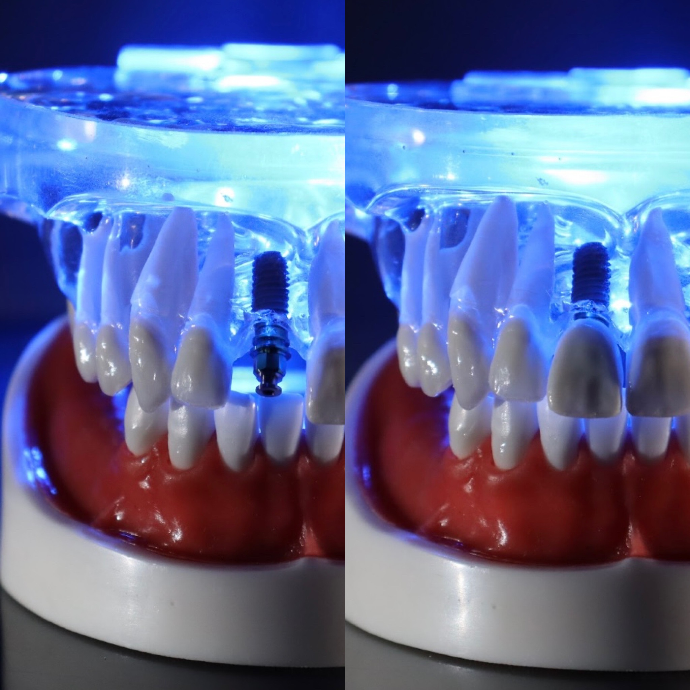

July 2024

Fesmire Dental Presents

# Tooth Replacement Therapy

Fesmire Dental offers Implants as a Tooth Replacement Therapy option. Implants can be used for a single tooth, multiple bridged teeth, or full arch replacement. The process may seem long, but a full tooth replacement is worth the wait. If a tooth is already missing the process can take between 4-6 months. If a tooth needs to be extracted first the process is 6-8 months. Your body needs time to heal in between each step of this process. Once the crown is place in the final process, you can expect your implant to last up to 20 years. Implant technology has improved with guided surgeries, better materials, and an innovative way to closely match tooth function.

How Does It Work?

Check out this short video…

[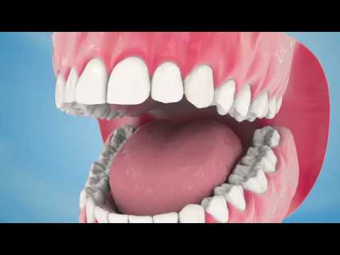](https://www.youtube.com/watch?v=DZ2lDxO4LCc)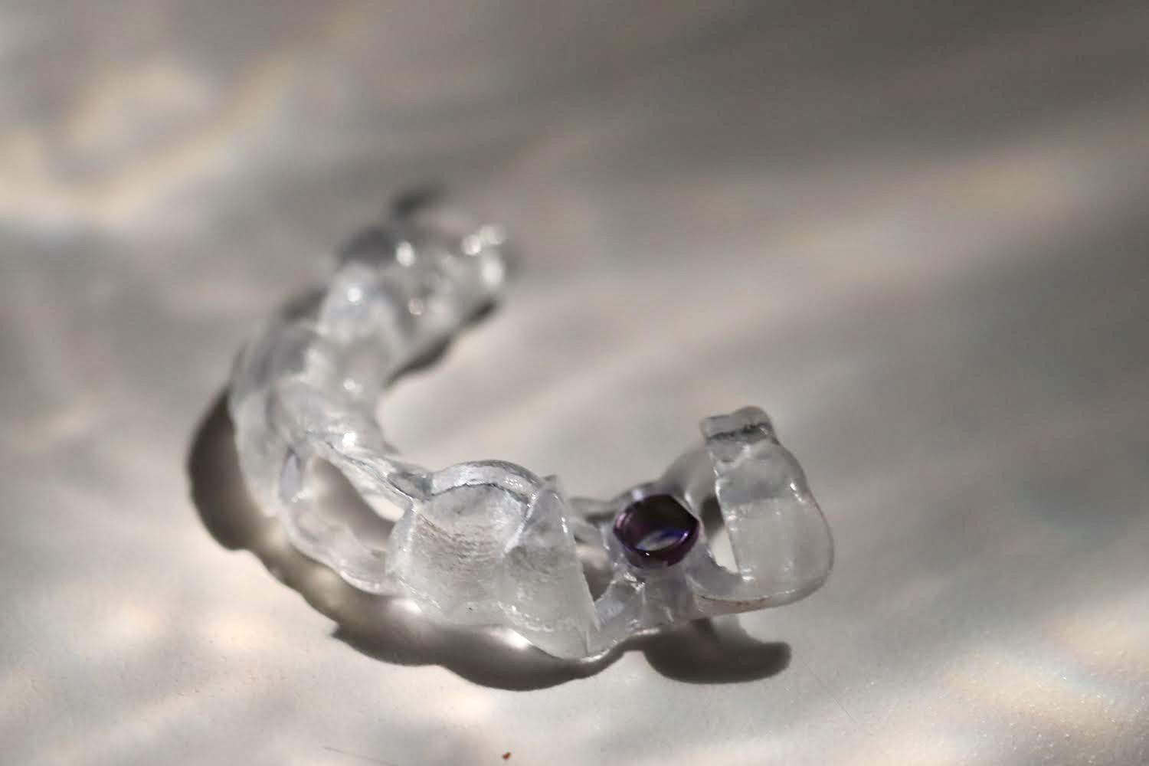

## Get Connected

If you are curious about tooth replacement therapy, call our office and schedule a consult! We would be happy to lead you in the right direction.

Our office is located at

106 Cude Lane, Madison, TN 37115

Office Hours :

Monday - Thursday

7:00 am to 3:00 pm

Phone: 615-865-1733

